**MQ 9 installation in Linux**

Pre-requisites:-

1. Linux 7 operating system



2. User "mqm" user and group "mqm" should be created. mqm user should be member of "mqm" group



3. File systems /var/mqm and /opt/mqm should be created

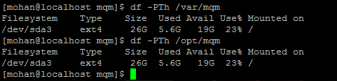

4. Have the appropriate MQ software dump in a temporary location

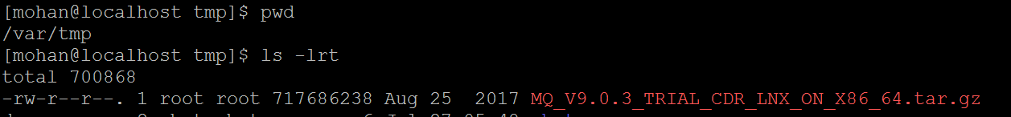

5. Have the access to switch to "root" user

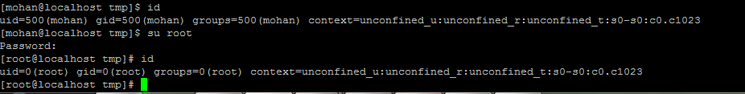

Installation procedure

1. Switch to "root" user

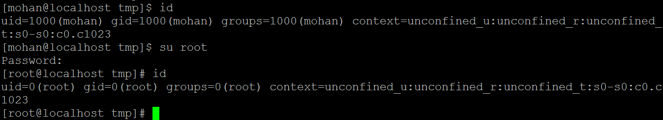

2. Go to the path where the MQ software dump is placed and Untar the MQ software



Now unzip and untar with below commands:-

To Unzip :-



To Untar:-

tar -xvf MQ_V9.0.3_TRIAL_CDR_LNX_ON_X86_64.tar

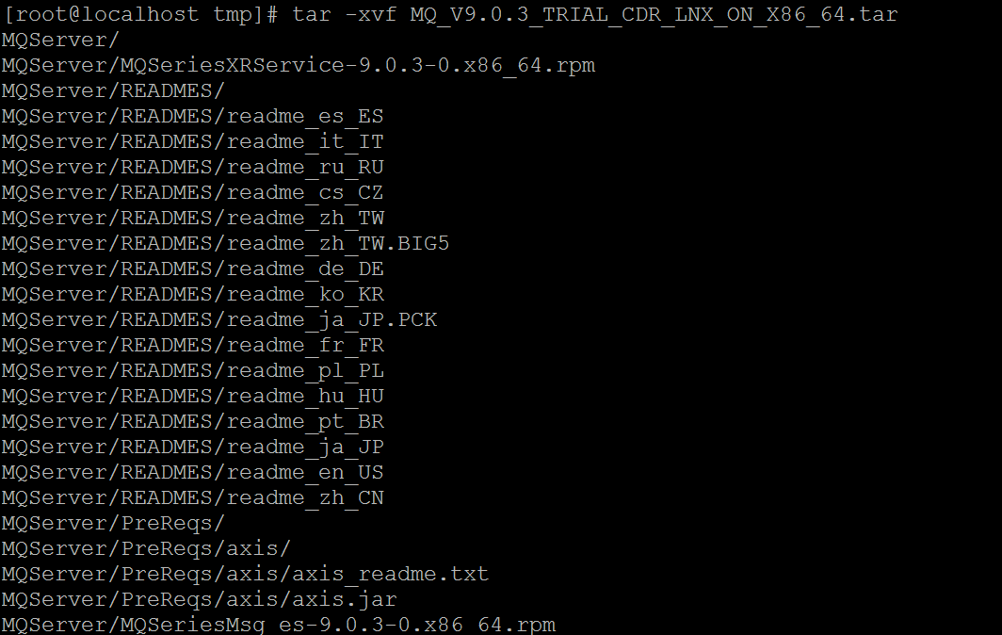

Now a separate directory will be created with name "MQServer" and packages will be displayed in the MQServer directory



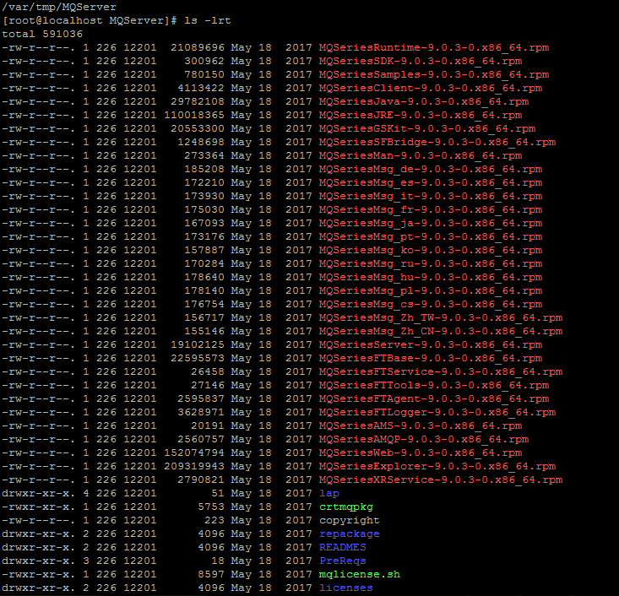

3. Accept the MQ license with the command "./mqlicense.sh -accept"

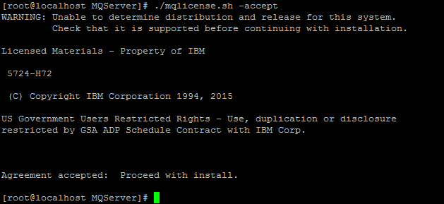

4. Installing the rpm packages

Note: Packages should be installed in the below specific order

i) MQSeriesRuntime-9.0.3-0.x86_64.rpm package must be installed first

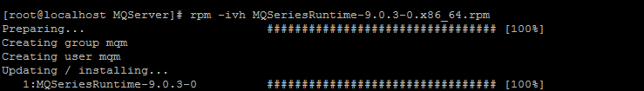

ii) Now you can install the Java packages

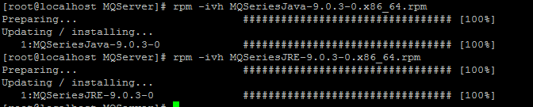

iii) Now install the remaining mandatory packages in any order

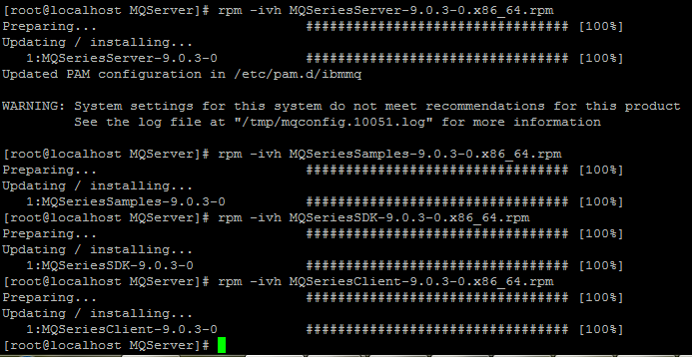

5. Check the packages if they are installed success or not by "rpm -qa |grep -i mq"

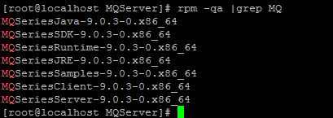

6. Now the check the MQ configuration met or not in the system using the command /opt/mqm/bin/mqconfig

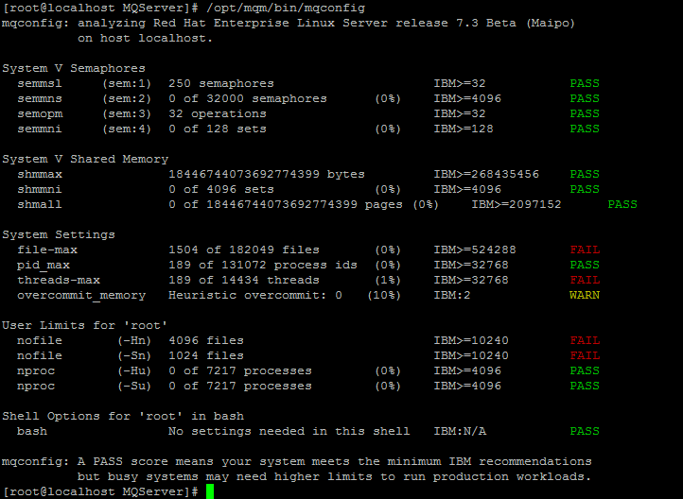

Everything should be in "PASS".

7. Now set as primary install

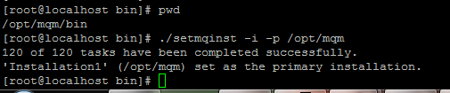

Installation has been successfully finished now. You can now switch to mqm user and then you can execute the MQ commands